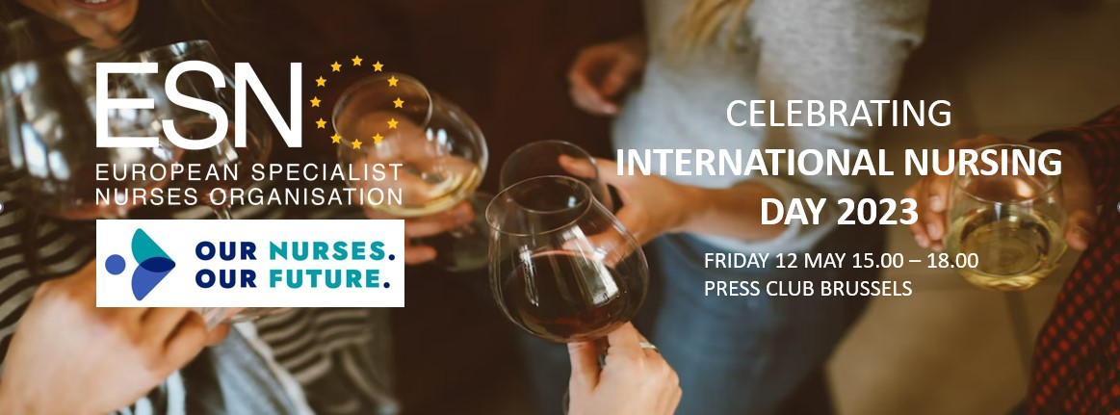

PROGRAM 12 MAY INTERNATIONAL NURSING DAY CELEBRATION

15.00 | Open doors and Registration
16.00 | Presentations | Welcome words  - ESNO, ‘an organisation in evolution’  - Bucharest Declaration on HWF, the ESNO response  - Nurses roles and responsibilities in Vaccination  - Launch of the Nurses Guide on Reading and understanding Scientifical Articles  - Launch, ESNO Nurses Pool and Indexation Survey
16.30 | Guests to speak | MedTech Europe  European Public Health Alliance  VIATRIS  EFPIA / Vaccines Europe  ZN Consultancy  European Observatory  Health First Europe  European Health Management Association  European Commission – TBC  PANXEA
17.00 | Drinks: Raising a glass, to the nurses in all domains of health.
18.00 | Closing and Wrapping up.

